Displaying Blocks
Use margins and paddings to adjust the spaces between divisions and use the display property to be able to put each block in its proper place.
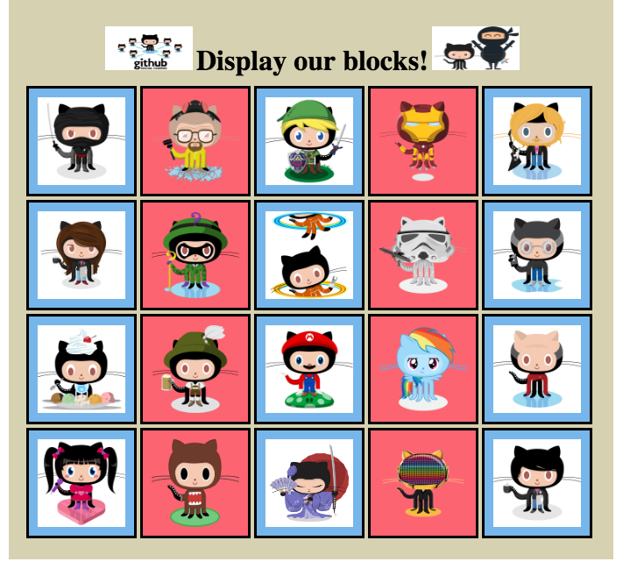
- Upload your updated HTML and CSS code here. Make sure that your HTML and CSS files are saved in a single folder. Have the folder compressed/zipped before uploading.

